HISTORIC RACING CAR ASSOCIATION

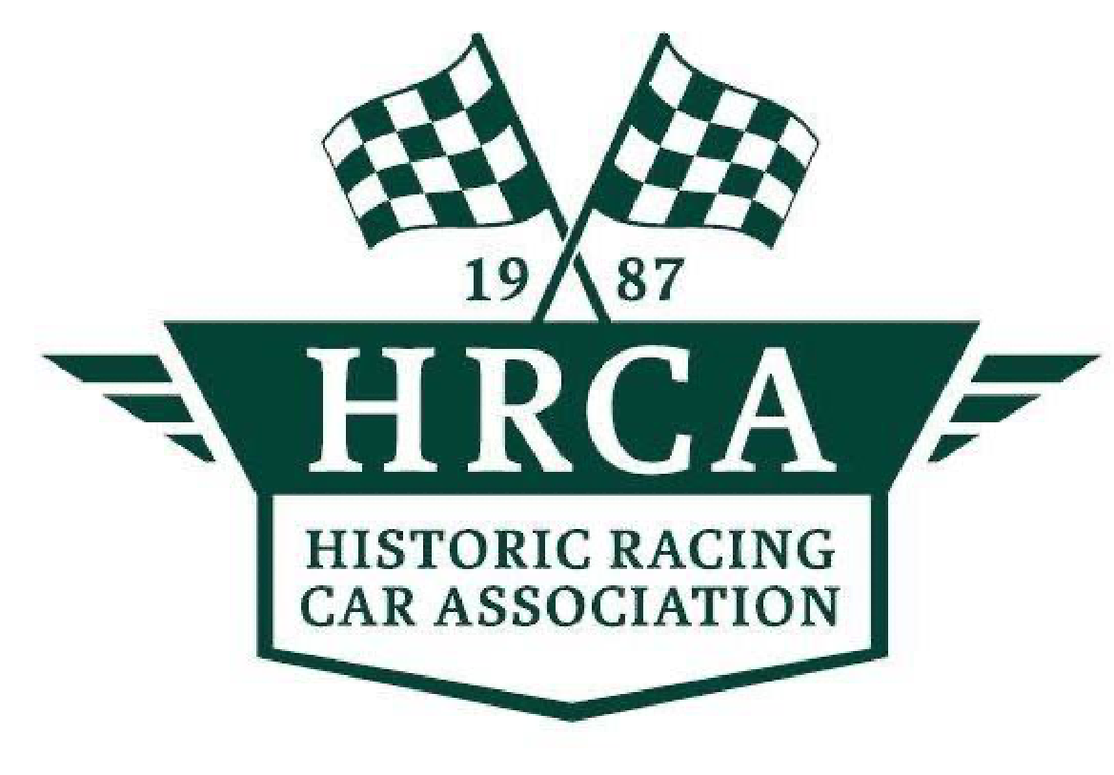

2023

SPORTING & TECHNICAL REGULATIONS



# 

# SPORTING REGULATIONS

## 1. THE CHAMPIONSHIPS

1.1 Introduction

The Championships will be run in accordance with the GCRs of Motorsport Ireland (“MI”), the International Sporting Code of the F.I.A and these rules, and the Historic Racing Car Association (“HRCA”) Technical Regulations will constitute the supplementary regulations.

1.2 Promotion

The HRCA and its sponsors will promote a series of championship and non-championship events in conjunction with MI affiliated clubs over the season incorporating events chosen from the hill climb and racing calendars.

1.3 Eligibility

The MI/HRCA Championships are open to competitors who are members of the HRCA and have registered for same and whose cars comply with the published HRCA Technical Regulations.

The Race Committee will publish annually on the MI web site the current Technical Regulations for all approved Championship Classes.

1.4 Sponsorship

The HRCA may secure sponsorships. All competitors must display championship sponsors decals as provided to their car or they may be excluded from the race results. Personal sponsor’s decals may be displayed on cars but must not be larger than the championship sponsor’s decals.

## 2. THE GEORGE MANGAN TROPHY

2.1 The George Mangan Trophy is for Pre 1980 classes.

2.2 Permitted classes are A,B,C and D as defined in the HRCA Technical Regulations.

2.3 All HRCA members in eligible cars will compete for the George Mangan Trophy, which will be based on a combination of races run at accredited circuits and rounds of the MI Hill Climb Championship.

2.4 The number of rounds counting is per the HRCA racing calendar with the number of dropped rounds as stated on the programme for each year. The racing calendar will be published by MI Bulletin and on the MI web site.

2.5 All hill climbs will be run on a handicap basis. Handicaps will be allocated by the MI Hill Climb Committee.

2.6 Points for races counting towards the George Mangan Trophy will be scored depending on the finishing time for each competitor adjusted according to a rolling handicap formula to calculate an adjusted race time which will determine the position in the race.

The basis for calculating the handicap to be applied at each race will be as follows:

* The handicap is calculated based on the results of the last race in which the competitor was a classified finisher.
* For the first race of the season, the handicap will be the last handicap from the previous season. New competitors will race with a scratch handicap for their first race.
* Handicaps are calculated by dividing the fastest driver/car combinations fastest lap in each race by the specific driver/car combination’s fastest lap and expressing this as a number.
* The driver/car combination’s actual race time will then be multiplied by this number to calculate an adjusted race time.
* In the event that a driver/car combination fails to complete the number of laps of the leading car/driver combination, his total race time will be calculated by adding to his actual finish time a time calculated by multiplying his average lap time in the race by the number of uncompleted laps when compared to the leading driver/car combination.
* Handicaps are applied to total race times.

2.7 The winner of the George Mangan Trophy in any year will not be eligible to receive an annual award in either the Frank Cassidy Perpetual Trophy or the Frank Cassidy Trophy in that year.

## 3. THE IMPACT IRELAND (METALS) LIMITED SCRATCH CHAMPIONSHIP

3.1 Cars that are eligible for any of the Irish Historic, UK Historic or European Historic Championship may compete in this Championship under their own Technical Regulations subject to the approval of the Class Championship Registrar.

3.2 Races will be run on a scratch basis for the Glen of the Downs Trophy.

3.3 The number of counting rounds is as per the HRCA racing calendar with two dropped scores. The racing calendar will be published by MI Bulletin and on the MI web site

## 4. THE HERITAGE PLATE

4.1 The Heritage Plate is awarded to the Pre 1974 Class winner in selected events.

4.2 The selected events will be published to all registered competitors in advance of the first championship round.

## 5. PRE WAR AND PRE 1955 CHALLENGES

5.1 In the Pre War and Pre1955 Challenges competitors compete for the IVVC Sports Section Cup and David Dunn Trophy.

5.2 No car/driver can be awarded both the Pre War and the Pre 1955 challenge awards. If a driver has won both then they will be presented with the IVVC Sports Section Trophy (the pre-eminent trophy) and will forgo receipt of the other award.

5.3 Handicapping for the internal HRCA Challenges will be managed in the following manner. Hill Climbs:

* Handicaps for the first day will be in accordance with the Class 4 MI handicaps on the day.
* Handicaps for the second day will be adjusted in accordance with the pre-determined formula and applied by agreement of two class drivers and with reference to the results of the first day and historic records. These will be posted in a prominent place and before the first run of the day.

Races:

* Handicaps will be set out following qualifying by agreement of two drivers at the meeting. Handicaps will be set in accordance with a pre-determined formula and applied by agreement of the two selected of two selected class drivers and with reference to the results of qualifying time sand historic records. The race handicaps will be posted in the paddock at least 30 minutes before the race
* The method of selecting the two drivers and the pre-determined formula will be published to all registered competitors in advance of the first championship round.

5.4 Points will be awarded on a double point’s basis for all races. Handicapping of all cars competing in the George Mangan Trophy or any other Championship event will be in accordance with MI Regulations.

5.5 When a HRCA race and a PRE 55 race clash at the same race meeting that points towards the George Mangan be awarded for both races as the handicaps for both classes are calculated by the same system. If a competitor enters both races he must declare before the race which race he wishes to score points.

5.6 Handicap awards be presented to paid up Members of the HRCA only.

6. PRESIDENT OF THE ASSOCIATION

The office of President of the Association will be appointed by the Committee biennially. Both current and past members qualify for appointment to this office. The membership of the Association will be formally notified once the appointment is made to this office.

The office is an honorary position without management responsibilities. The president will be kept informed of, but cannot interfere with, the business of the Association. The commitment of the President will be to attend HRCA and other events as requested by the Committee and to promote the Association.

If the President resigns during the term of office, the Committee will appoint an Interim President to the end of the retiring President’s term of office. This interim appointment will be formally notified to the Members

## 6. POINTS SCORING

6.1 Points scoring will be in accordance with Appendix 15: 6.1.3. of the current year book.

6.2 Resolution of ties will be per Appendix 15; 6.10. of the current year book.

6.3 Class Championship Registrar shall be David Moloney (contact details)

## 7. PRESENTATION

All cars must be presented in a condition that will boost the reputation of the HRCA. The Class Scrutineer may ask a competitor to improve the presentation of any car that is not in keeping with the spirit of the HRCA.

## 8. CONTACTS

8.1 Class Principal: Conor Cooke

8.2 Class Scrutineer: MI Panel

# TECHNICAL REGULATIONS

## 1. PERMITTED CAR CATEGORIES

1. Standard production saloons, sports and GT cars manufactured before 31st December, 1974.

1. Sports racing cars and specials, modified sports, GT cars and saloon cars manufactured before 31st December, 1979.

1. Standard production saloons, sports, GT cars and historic rally cars manufactured before 31st December,

1979

1. Continuation cars with HTTP papers and kit cars manufactured before 31st December, 1979

1. Pre war and pre ’55 cars as per their individual Technical Regulations within the HRCA.

1. Invitation cars running on E rated tyres in the spirit of historic racing as agreed with the Eligibility Scrutineer and the Class Principal. These cars will be permitted to compete in the Race Championship for the Frank Cassidy Trophy.

1. Rear wheel drive standard production saloons and sports, GT cars and historic rally cars manufactured before 31st December 1983 in the spirit of historic racing by agreement with the Class Principal and the Eligibility Scrutineer, to compete for the Race, Hill Climb and Impact Ireland (Metals) Limited Scratch Championships.

To include cars such as those that follow on the list below.

All late model MGB and MG Midgets, MG Metro, Davrian Mk8, TMC Costin, Rover SDI, BMW3 Series, Ford Escort Mk2, Ford Capri 3 ltr, Morgan +8, Porsche 911 Turbo (Type 937), 911SC, 924, 928, 944, Triumph TR8, Toyota Celica Talbot Sunbeam Lotus and others to be agreed with the Class Principal and Eligibility Scrutineer.

No front wheel drive (unless named), no four wheel drive and no turbo charging unless standard.

## 2. TYRES

2.1 The use of racing slick tyres or cut slick tyres is not permitted.

2.2 Only standard production road tyres may be used. All tyres must be E rated road or threaded day tyres from the MSA lists 1a – 1c are allowed and have a thread depth of 1.6 mm postrace. The FIA Homologated Historic Dunlop CR65 tyres, Avon Historic wet tyres and Avon All-Weather tyres may be used.

## 3. INTERIOR

3.1 Interior must be as per Appendix 2 in MI Yearbook

3.2 No radio communication devices are permitted on cars during practice or racing.

3.3 No data logging systems are permitted during practice or racing.

## 4. BODYWORK

4.1 On Category (A) cars, it is permitted to replace the front wings, bonnet and boot lid with panels of a non-standard period material. Front and rear bumpers may be removed. The original designed monocoque must be retained.

4.2 On Category (B) cars, the original floor plan of the production car must be retained.

4.3 On Category (A), (B), (C) and (D) cars front and rear lights must be retained in the original position.

4.4 The wheel base of the vehicle must be unchanged from the original production model.

## 5. ENGINE MOUNTINGS

The material of the elastic part of the engine mount and transmission mounting are free, but not the number of mountings. You may not alter the position of the mounting or its pickup points on the engine or chassis.

## 6. ENGINE

The engine block and cylinder heads must be of the original make, type, trademark, design and material and date from the same period. It should have the same number of cylinders and camshafts and be driven by the original method. Internals can be modified without restriction

7. FUEL SYSTEMS

Fuel systems are free, except that injection systems are not permitted unless fitted in period.

## 8. IGNITION

Electronic ignition is permitted. The distributor is free provided it retains its original drive and location. Limiters are permitted.

## 9. COOLING SYSTEMS

Changing the position of the radiator from that of the original production model beyond a tolerance of two inches is prohibited. However, the radiator fan and the switching mechanisms are otherwise free.

## 10. EXHAUST SYSTEM

The exhaust system is free but must not pass through the bodywork. The exhaust must exit at the side or rear of the car beyond the periphery of the car. Noise levels are as per NI Yearbook 105DB MAX.

## 11. GEARBOX

Gearbox is free provided there are no more than five forward gears. All modifications carried out must be of the period, with the exception of Ford (rocket, bullet, t9 and t5 Sierra) gearboxes which are permitted. No sequential gearboxes or derivatives are permitted.

## 12. REAR AXLE

Final drive ratios are free and a limited slip differential may be fitted. Anti- tramp bars and Panhard rods may be fitted to the rear axle castings. The original axle casting must be retained.

## 13. SUSPENSION

Period modifications only are allowed as well as the following:

* The ride height is free
* Anti-roll bars may be fitted or removed
* Lever arm shock absorbers may be replaced with telescopic type
* Camber is free

## 14. BRAKES

Period modifications only permitted, but discs may replace drums on the grounds of safety with the eligibility scrutineer’s agreement.

The use of dual brake master cylinders are permitted and strongly advised.

15. WHEELS

It is permitted to use wheels 2 inches wider or 2 inches larger in diameter than a production model.

## 16. PRE WAR AND PRE ’55 – SPECIFIC REGULATIONS

16.1 Permitted cars in Category (E) as defined in Clause 1 above will consist of the following period groups:

1. Veteran cars built before 01/01/1905
2. Edwardian cars built between 01/01/1905 and 31/12/1918
3. Vintage cars built between 01/01/1919 and 31/12/1930
4. Post Vintage Thoroughbred built between 01/01/1931 and 31/12/1936
5. Cars built between 01/01/1937 and 31/12/1955

* 1. Cars of periods (a) to (d) are exempt from the requirement of having a minimum distance between the top of the seat and the top of the adjacent body side of 152.5 mm, or having all seats facing forward. Seats may also tilt, hinge or fold.

* 1. Cars of periods (a) to (e) are exempt from the requirement of having the exhaust terminating behind the midpoint of the wheel base. Subject to circuit/ venue owner’s requirements, all cars will be subject to noise testing. The tests shall be carried out with the engines run at two-thirds maximum rpm.

* 1. Cars of periods (a) to (d) are exempt from the requirement to have a protected oil tank when it is situated outside the main chassis and may have the oil tank to the rear of the gearbox casing.

* 1. Cars of period (a) and (b) need not be fitted with sprung suspension if originally built without it.

* 1. When racing, cars built after 1930 must have brakes on all four wheels. When racing, cars introduced prior to 31/12/1934, are not required to have 25% minimum braking effort applied to each.

* 1. Cars of period (a) to (d) are exempt from the requirement to have steel wheel nuts of a minimum length.

* 1. When racing remoulded or re-threaded tyres may only be used on cars built prior to 1940.

* 1. In races, sprints and hill climbs, open cars of periods (a) to (e), are strongly recommended to have an external circuit breaker switch. When a circuit breaker is mounted on cars of periods (a) to (e), the mounting point may be approximately vertically below the line of the scuttle on the driver’s side. Cars of periods (a) to (e) may have the ignition components located in the cockpit.

* 1. When racing, cars are exempt from the requirement to fit a safety rollover bar unless it was required by the original Formula Regulations. For speed events, cars of period (a) to (e) are exempt from the requirement to have a rollover bar. Cars of periods (a) to (e) are exempt from fitting a safety harness.

## 17. SAFETY REGULATIONS

All cars must comply with Motorsport Ireland Appendix 2 Regulations regarding safety regulations If it does not say in these regulations that you can do it THEN YOU CANNOT.

## 18. MODIFICATIONS

All modifications of any kind to competing cars or any of their component parts must be of the period and materials used in that period.

In cases of period modifications, the onus of proving a modification as being period rests with the competitor who must submit documentary evidence.

Superchargers and turbo chargers are specifically banned under these regulations as add on modifications.

## 19. SCRUTINY/ELIGIBILITY

Competing cars may be sealed or checked by the Eligibility Scrutineer at any time or place convenient to him in order to ensure compliance with these Technical Regulations at the expense of the competitor concerned. Eligibility scrutineering may take place pre-season, during the season or post season depending on the scrutineer. Eligibility will be governed in accordance with MI Regulations. Penalty for an ineligible car found at scrutineering is the removal of all points in all the HRCA Championships.

In the event of a dispute over eligibility, the decision of the class Eligibility Scrutineer as to what constitutes an eligible part or car shall be final.

All cars must be presented at scrutiny in a clean and tidy condition, with presentable body and paint work, ready to compete. Championship sponsor decals and logos must be fitted to all cars in the designated position for same. Any car deemed not to be sufficiently well presented and judged by the scrutineer to be such as to bring the HRCA into disrepute can be deemed ineligible to compete.

## 20. REGULATIONS APPLICATION STATEMENT

In the spirit of the HRCA and promotion of historic racing, the above Regulations will be applied by the Class Scrutineer at his absolute discretion.

Certain deviations from the above Regulations may be permitted as long as they do not create an unfair performance advantage. The Class Scrutineer will determine on the matter of “unfair advantage”